Locomotion

Sava Stefan-Cristian

Voicu Mario Andrei

Straton Andre Antonio

A web application built with Angular. The website features three game modes:

* A GeoGuessr inspired game, in which the user is played on a 3d view somewhere in the world and is prompted to guess where they are. They receive a score based on their accuracy.
* An educative game in which the user places each country on the map, receiving and losing score points based on their guesses
* An educative game in which the user names the capital city of each country, receiving and losing score points based on their guesses

The main menu:

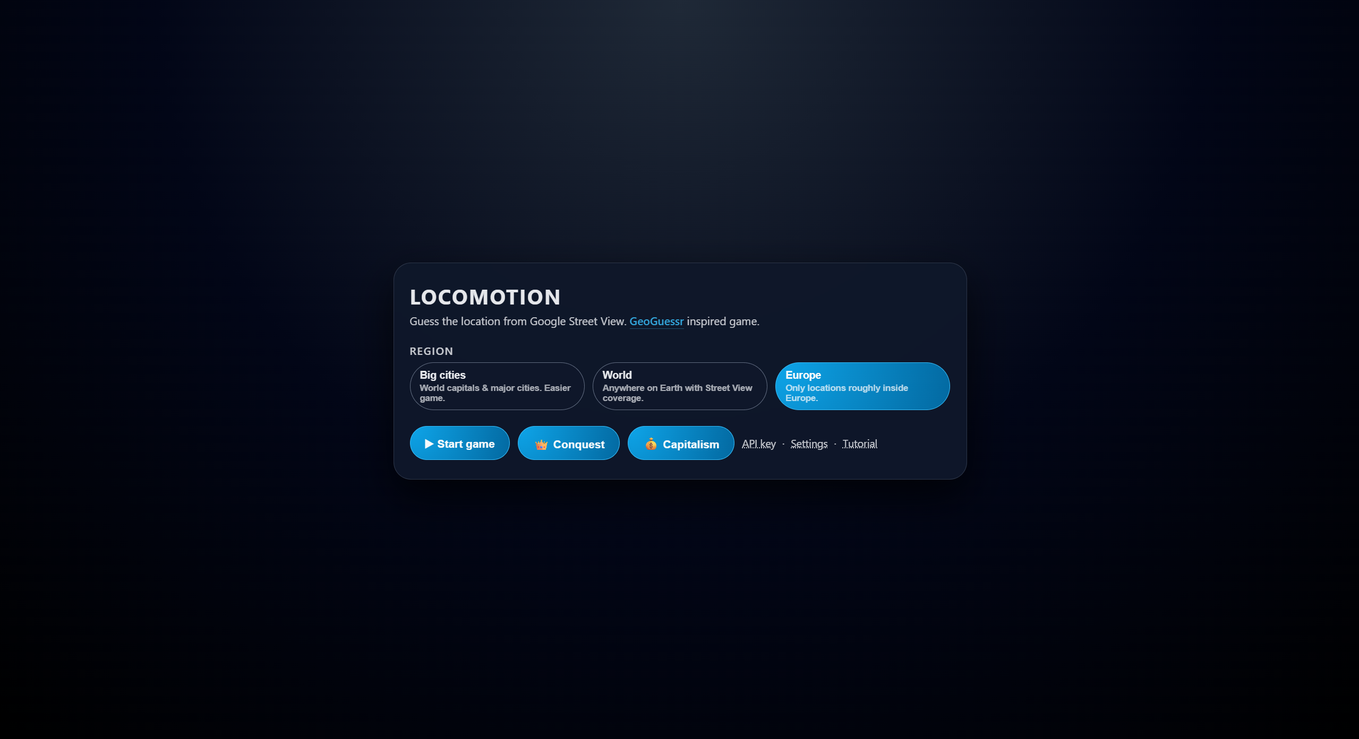

For the GeoGuessr game, the user has multiple areas to chose from.  
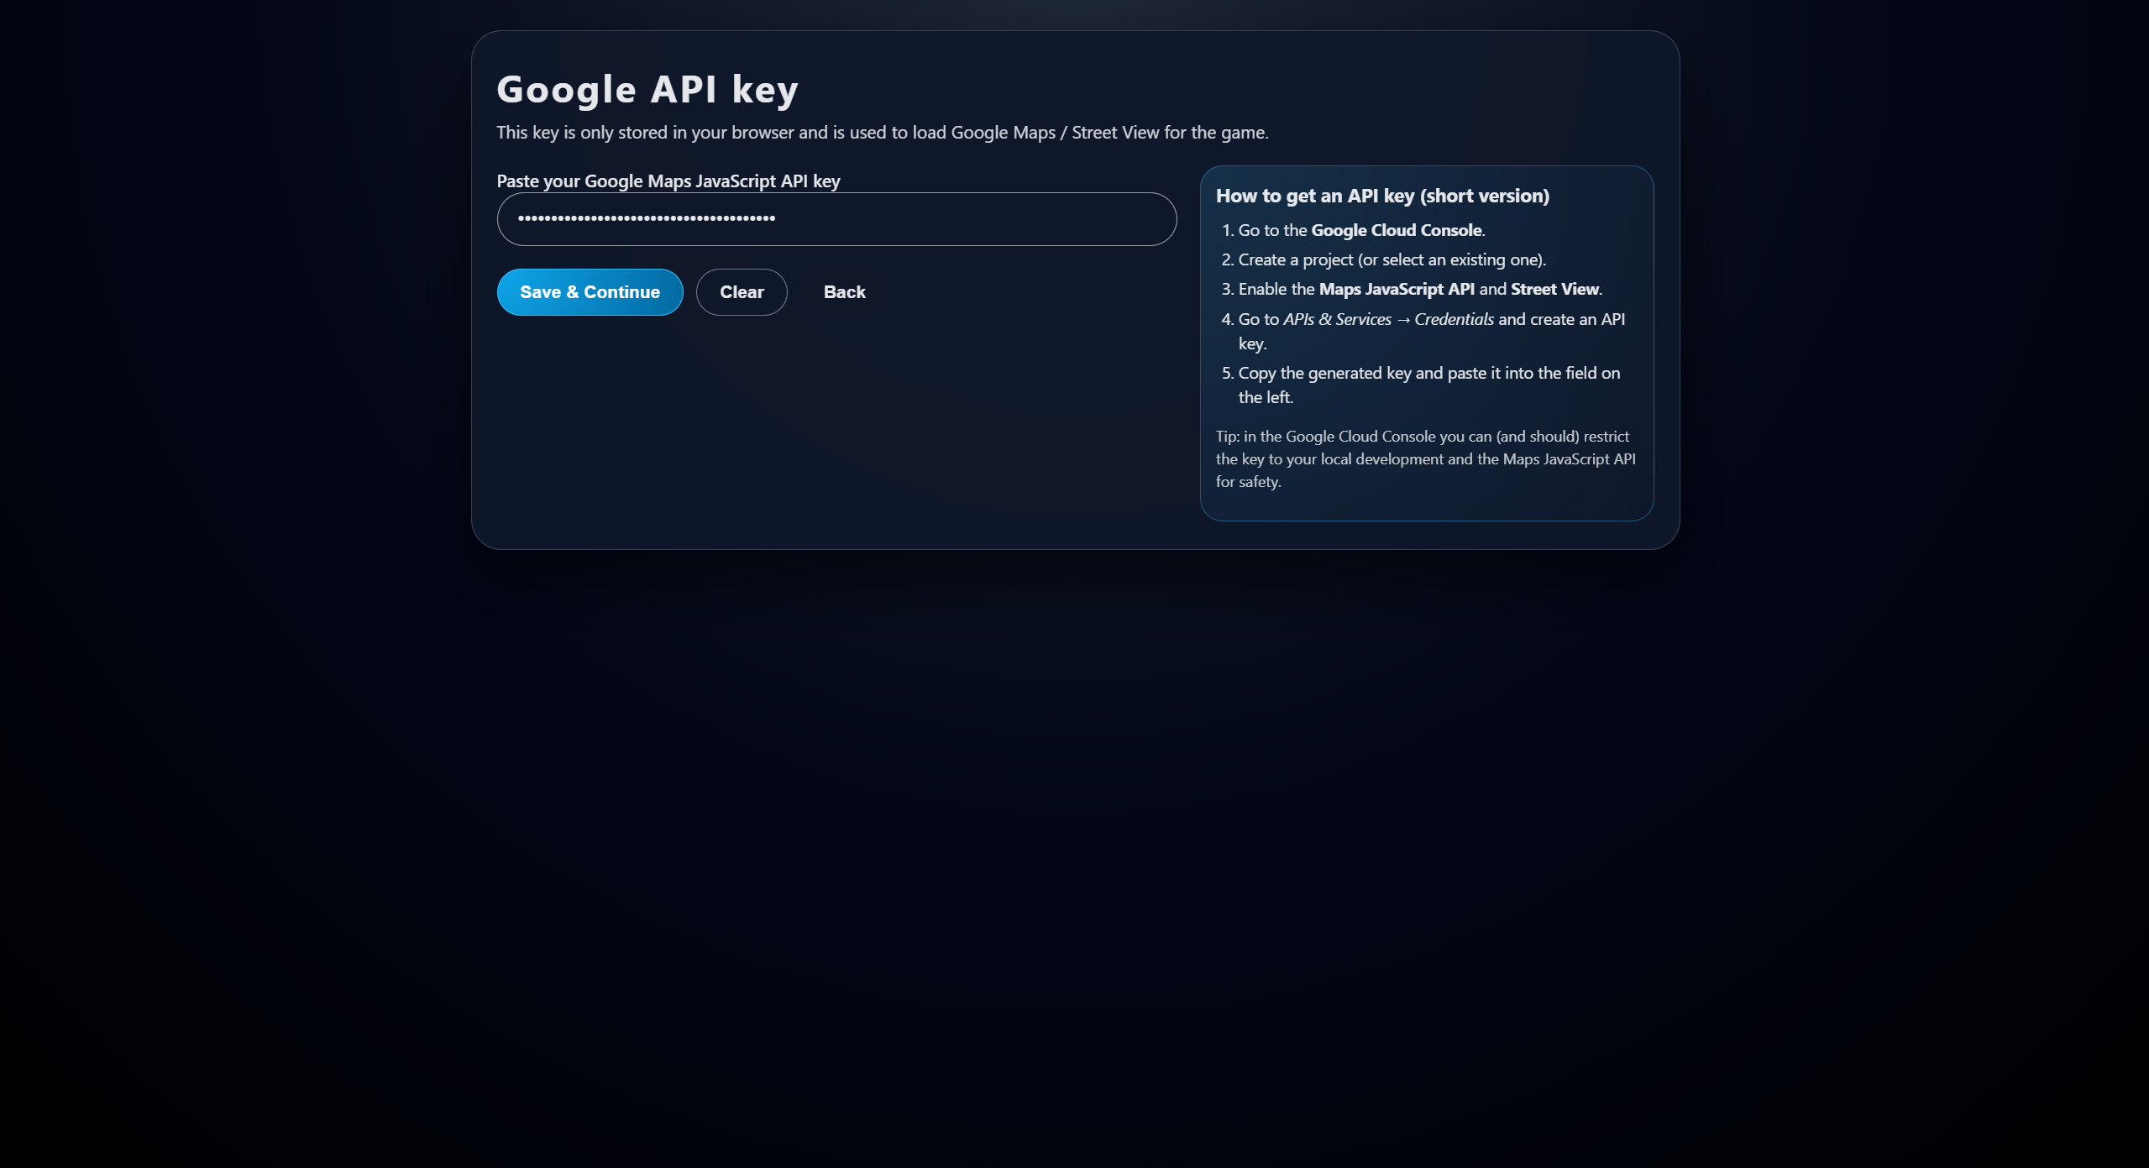

The GeoGuessr game requires an GoogleApi for Google Maps access. The game runs on a Bring-Your-Key basis.

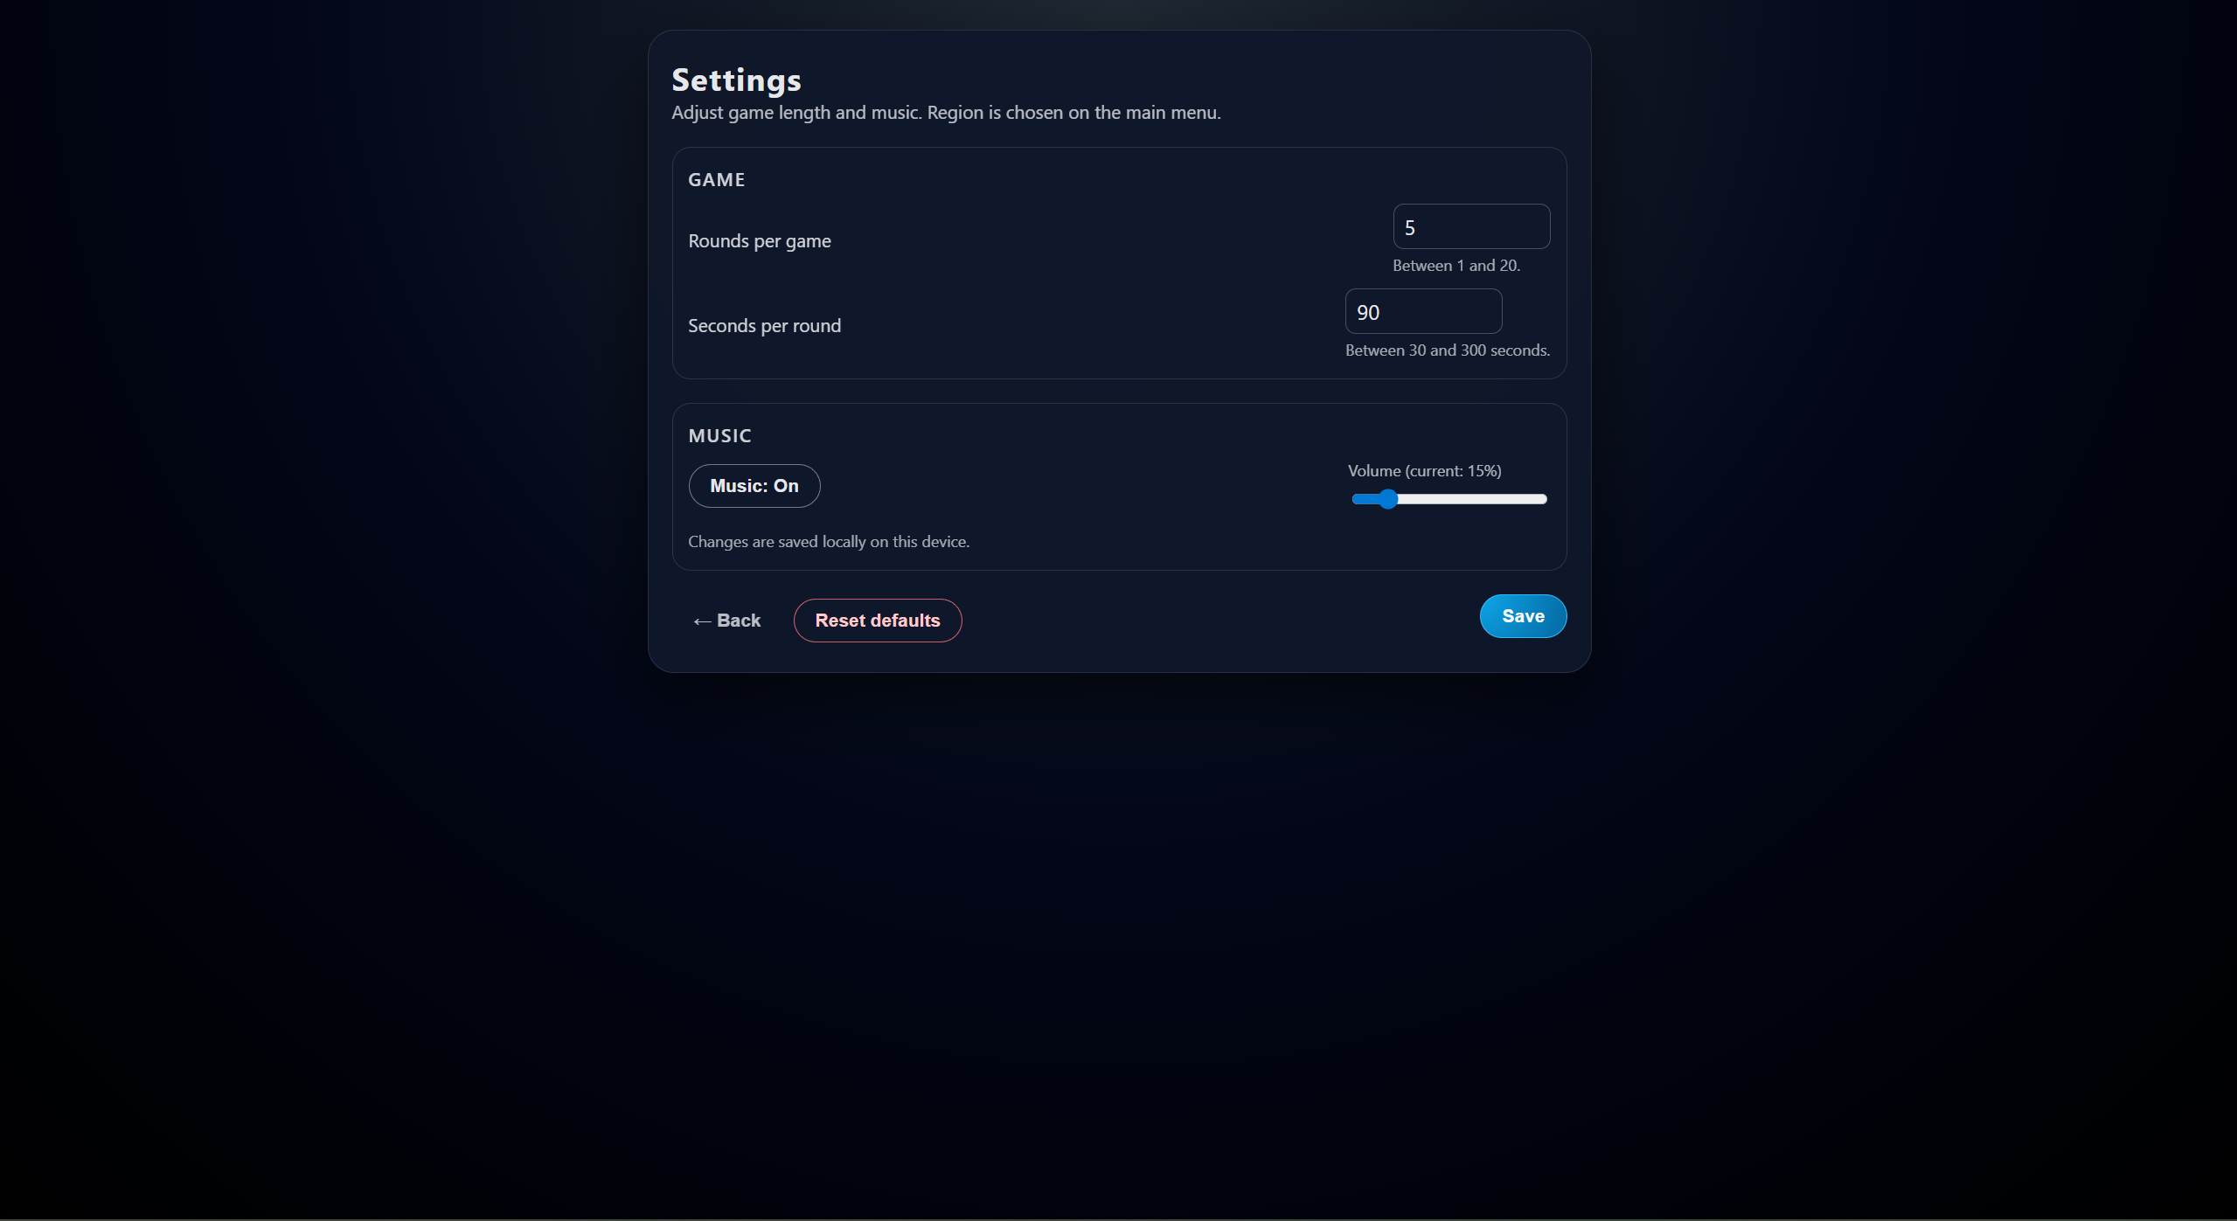

There is also a Settings screen for the GeoGuessr inspired game, in which the user can change the settings for the game.

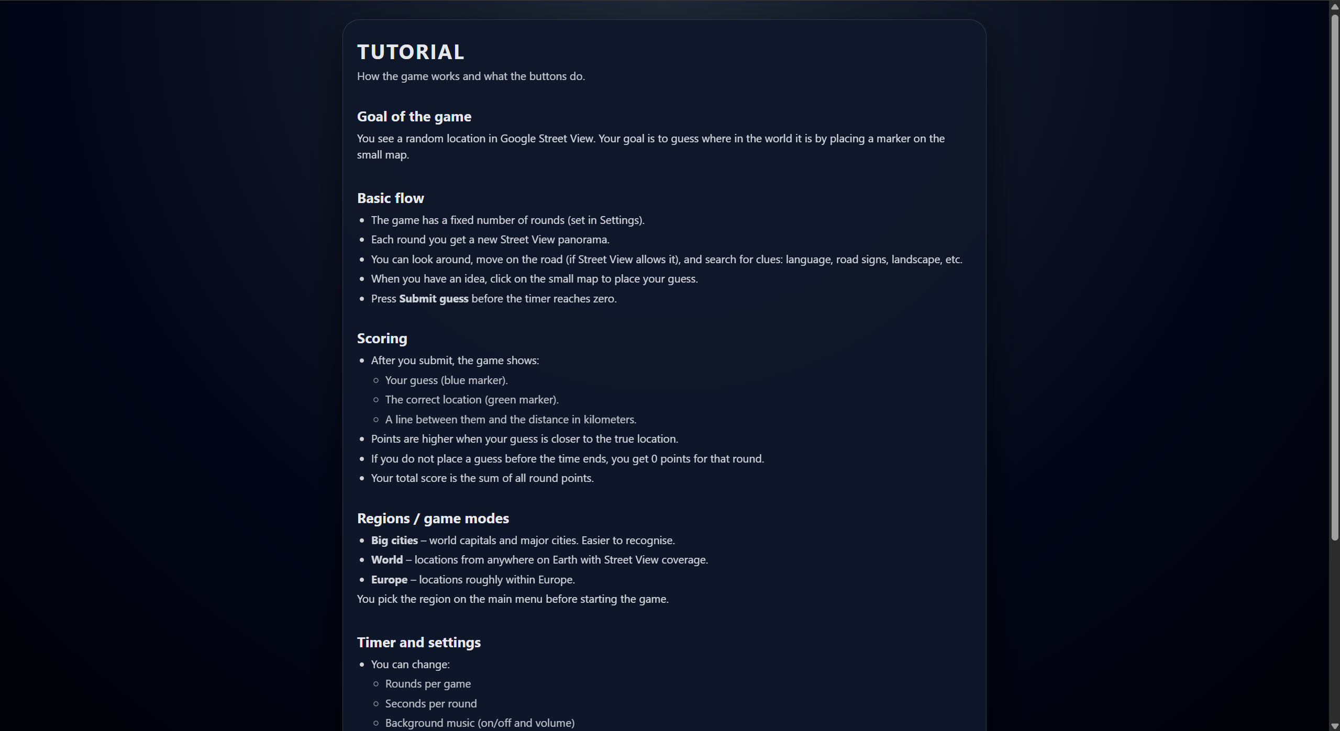

And a Tutorial page for the GeoGuessr game.

Gameplay Images for GeoGuessr game:  
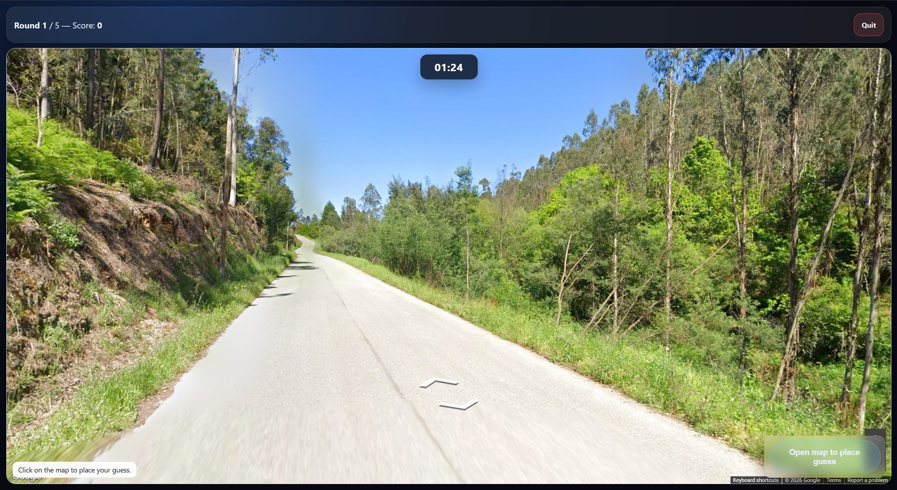

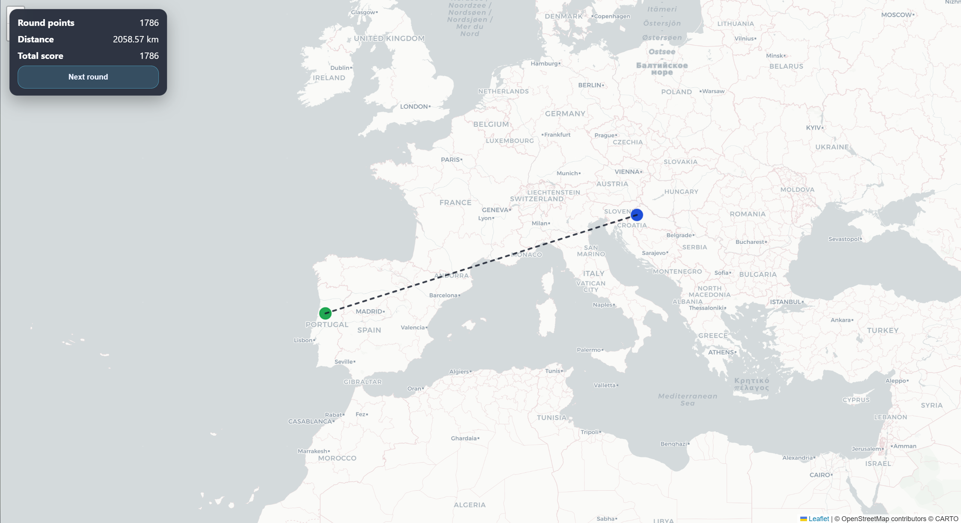

After completing all rounds, the user can visualize relevant information about the current run and previous runs, in a leaderboard manner.  
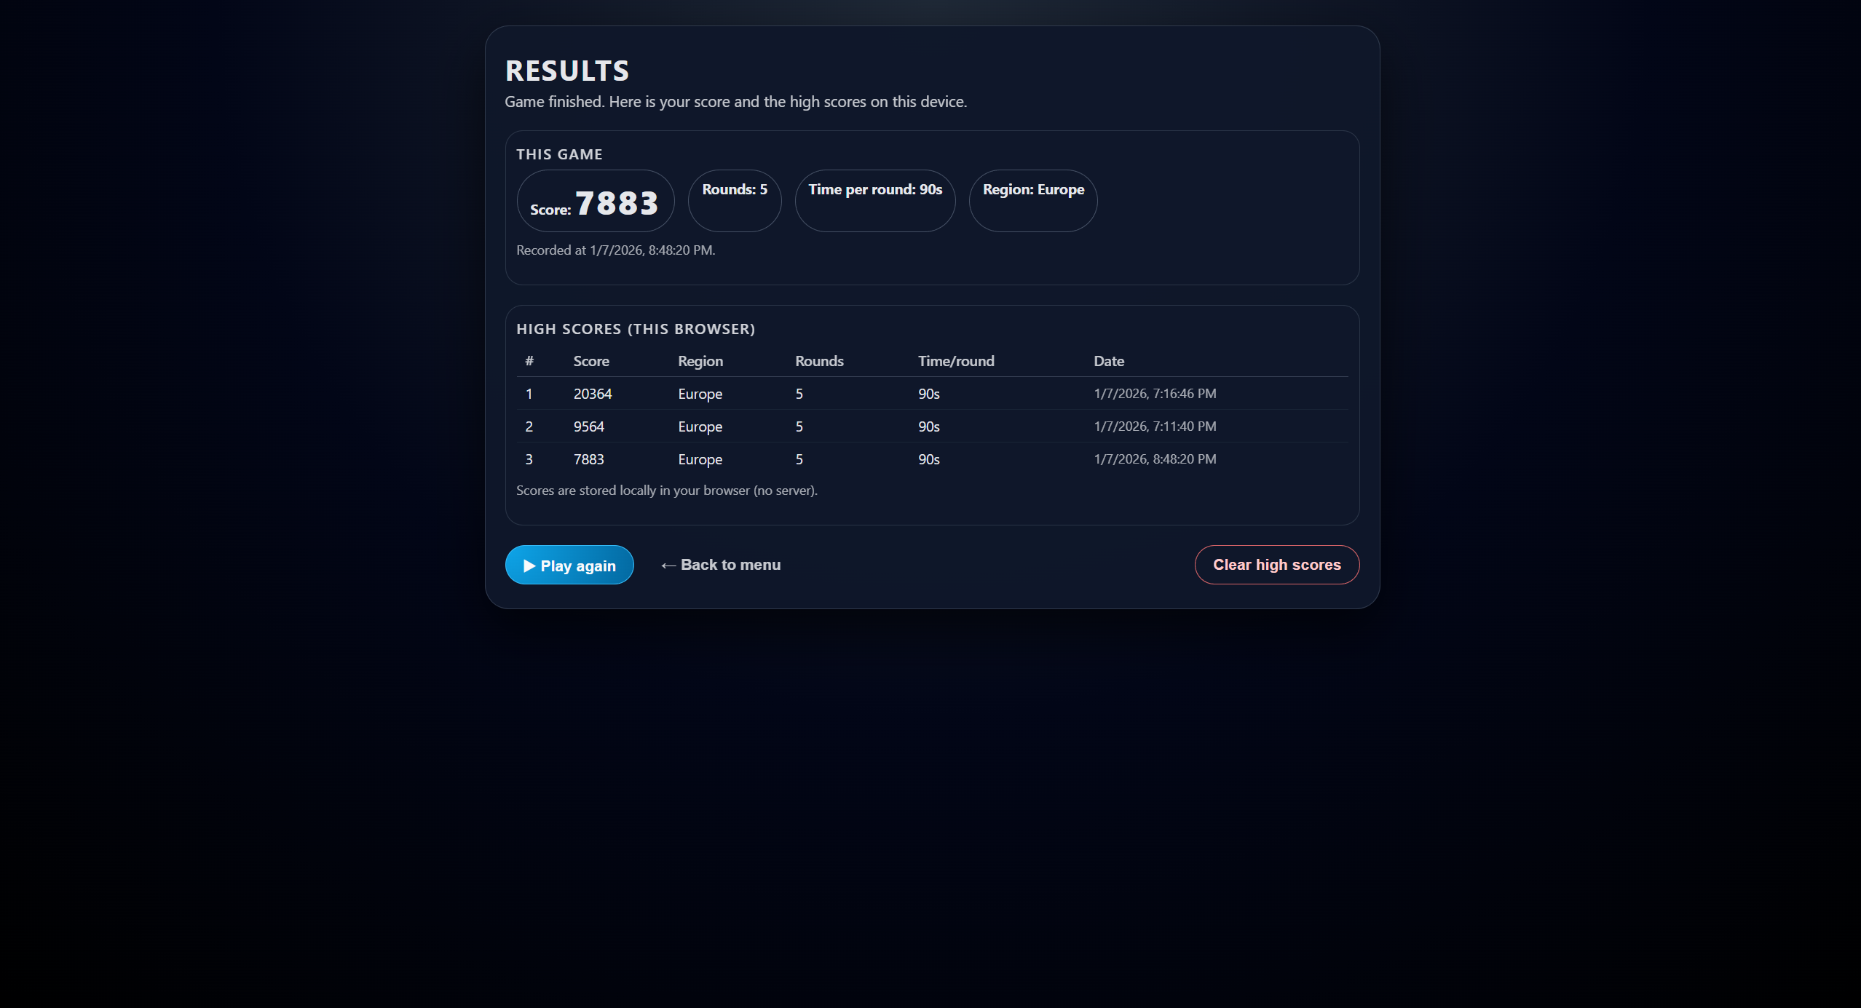

In fact, all three games feature a similar results page.

The Conquest Game:  
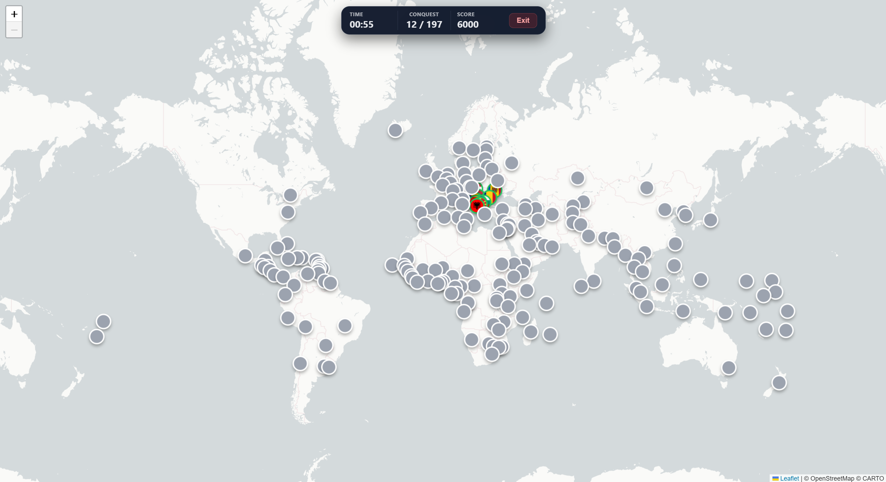  
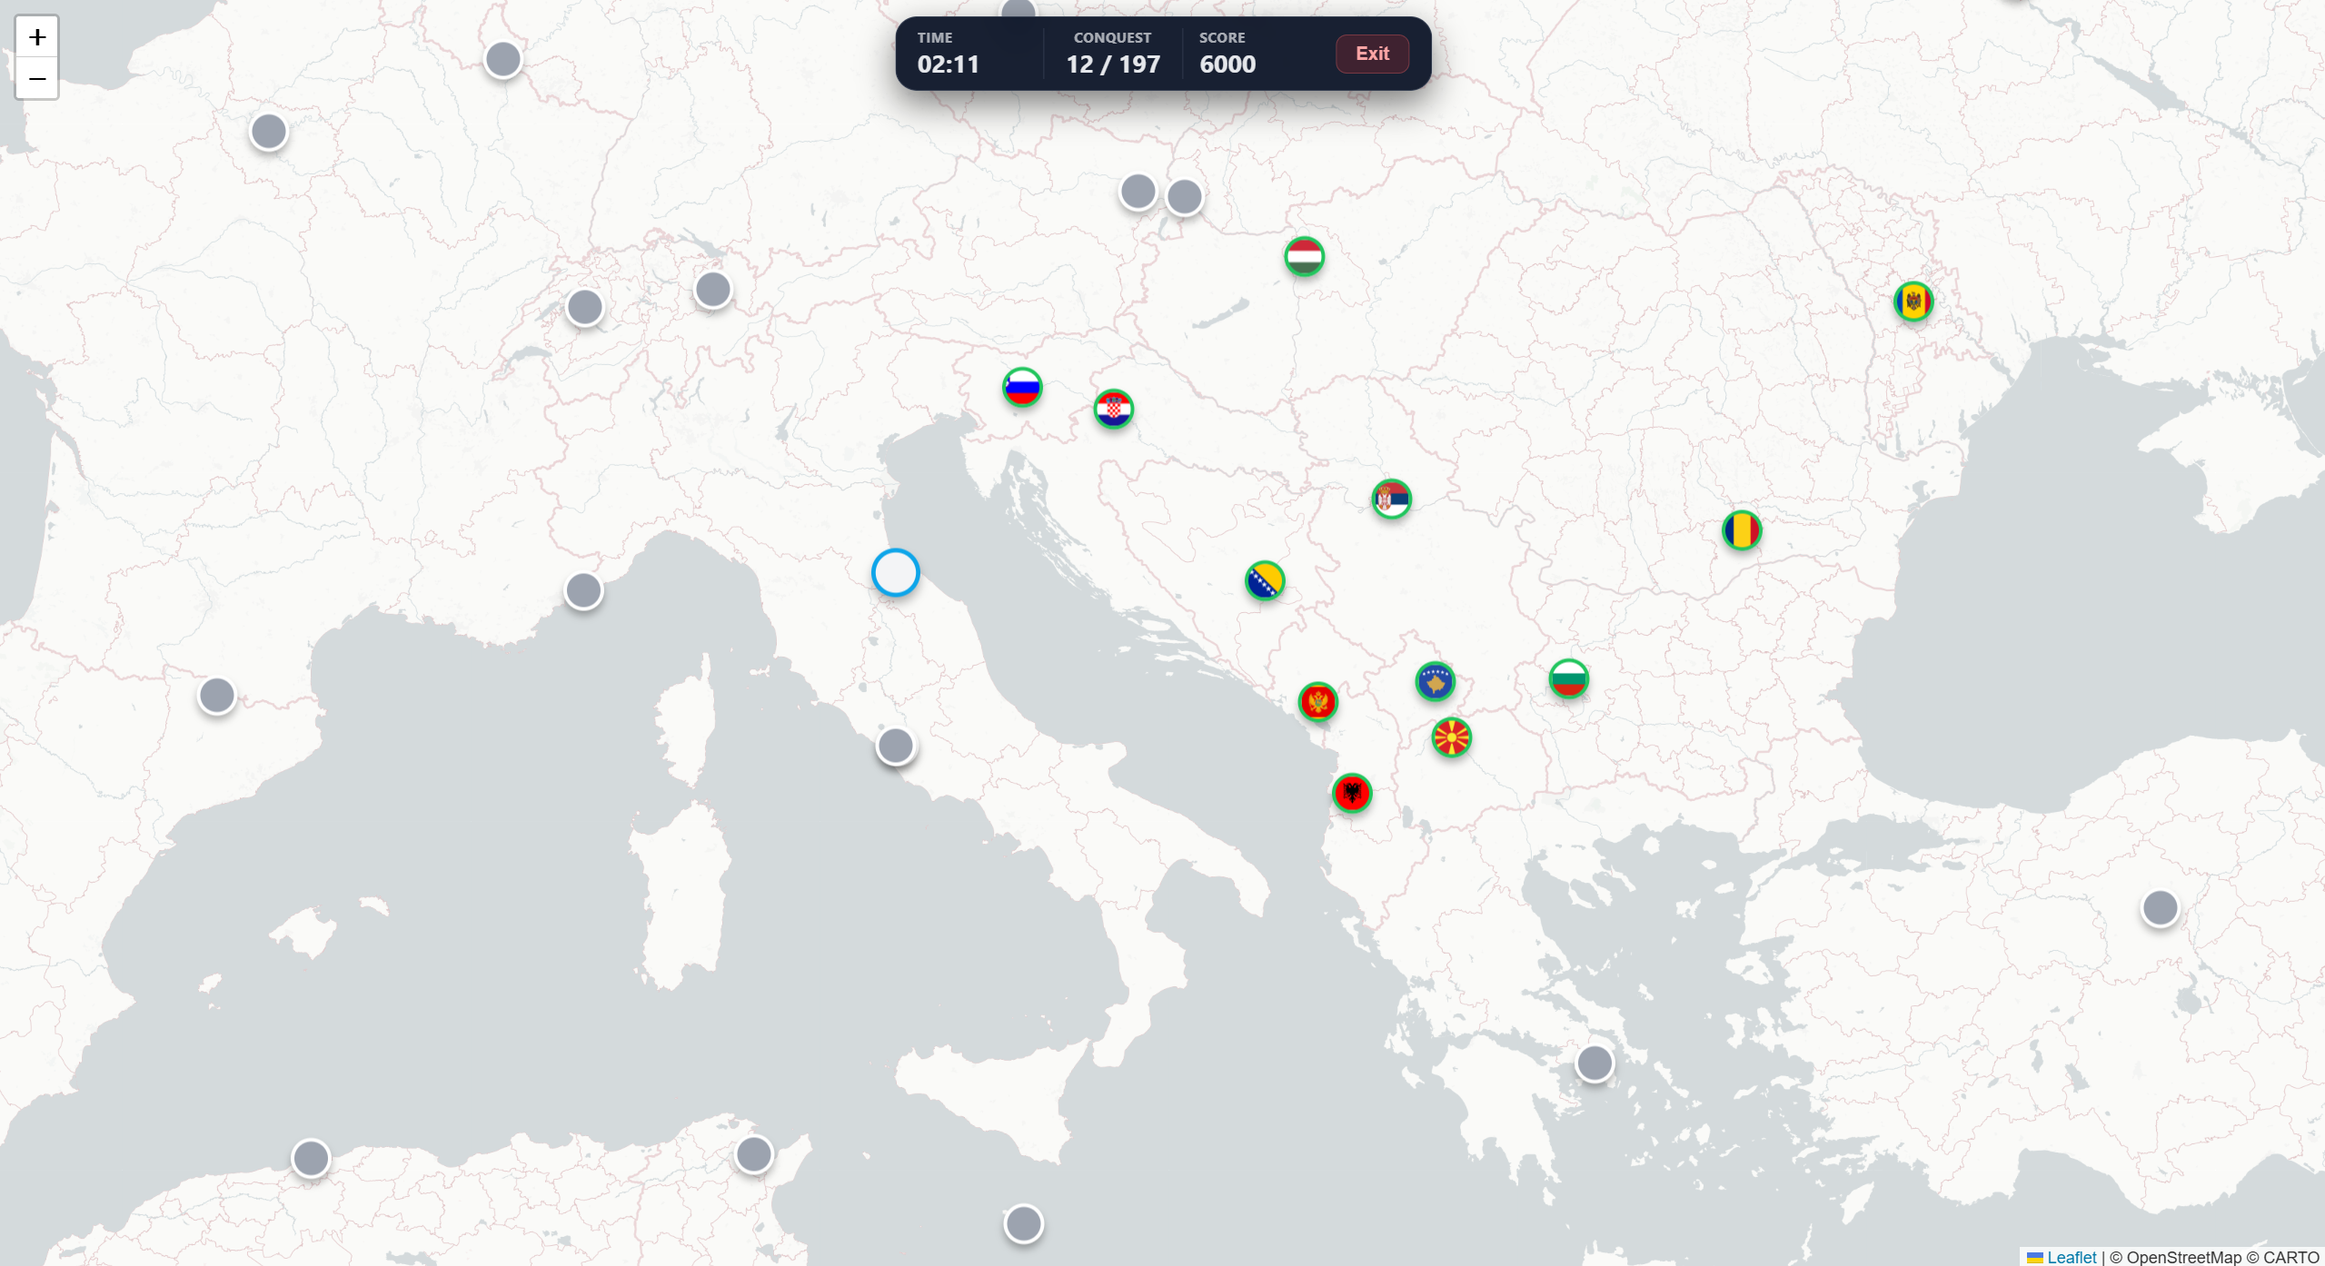

The user has a map of the globe. Clicking on one of the points opens a modal in which they can select the country that is there:

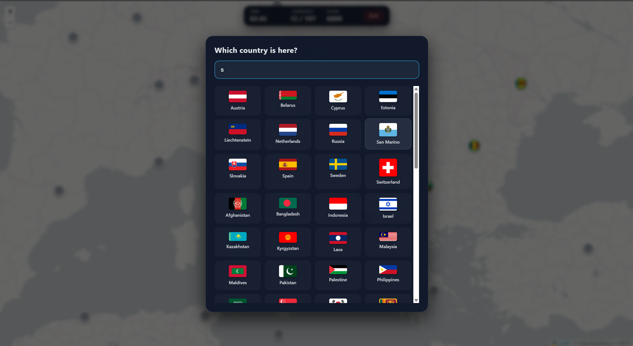

Guessing the correct country earns them points:

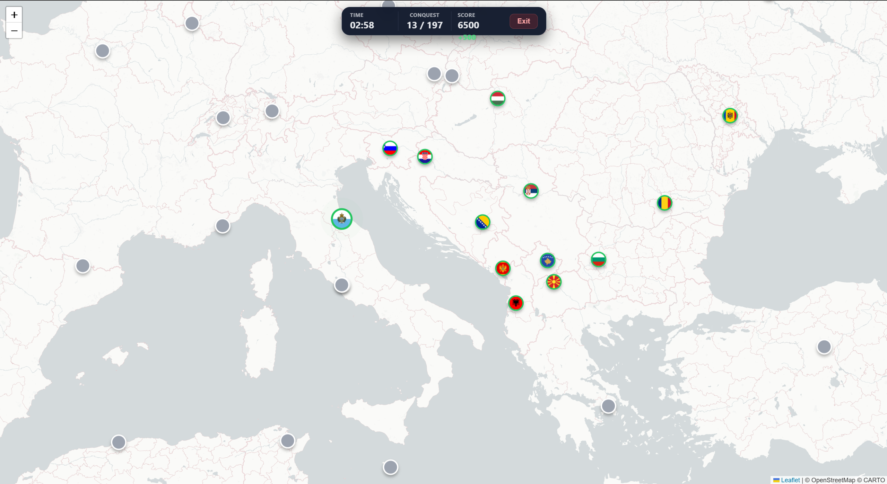

Guessing wrong losses points and prevents them for guessing for a few seconds:  
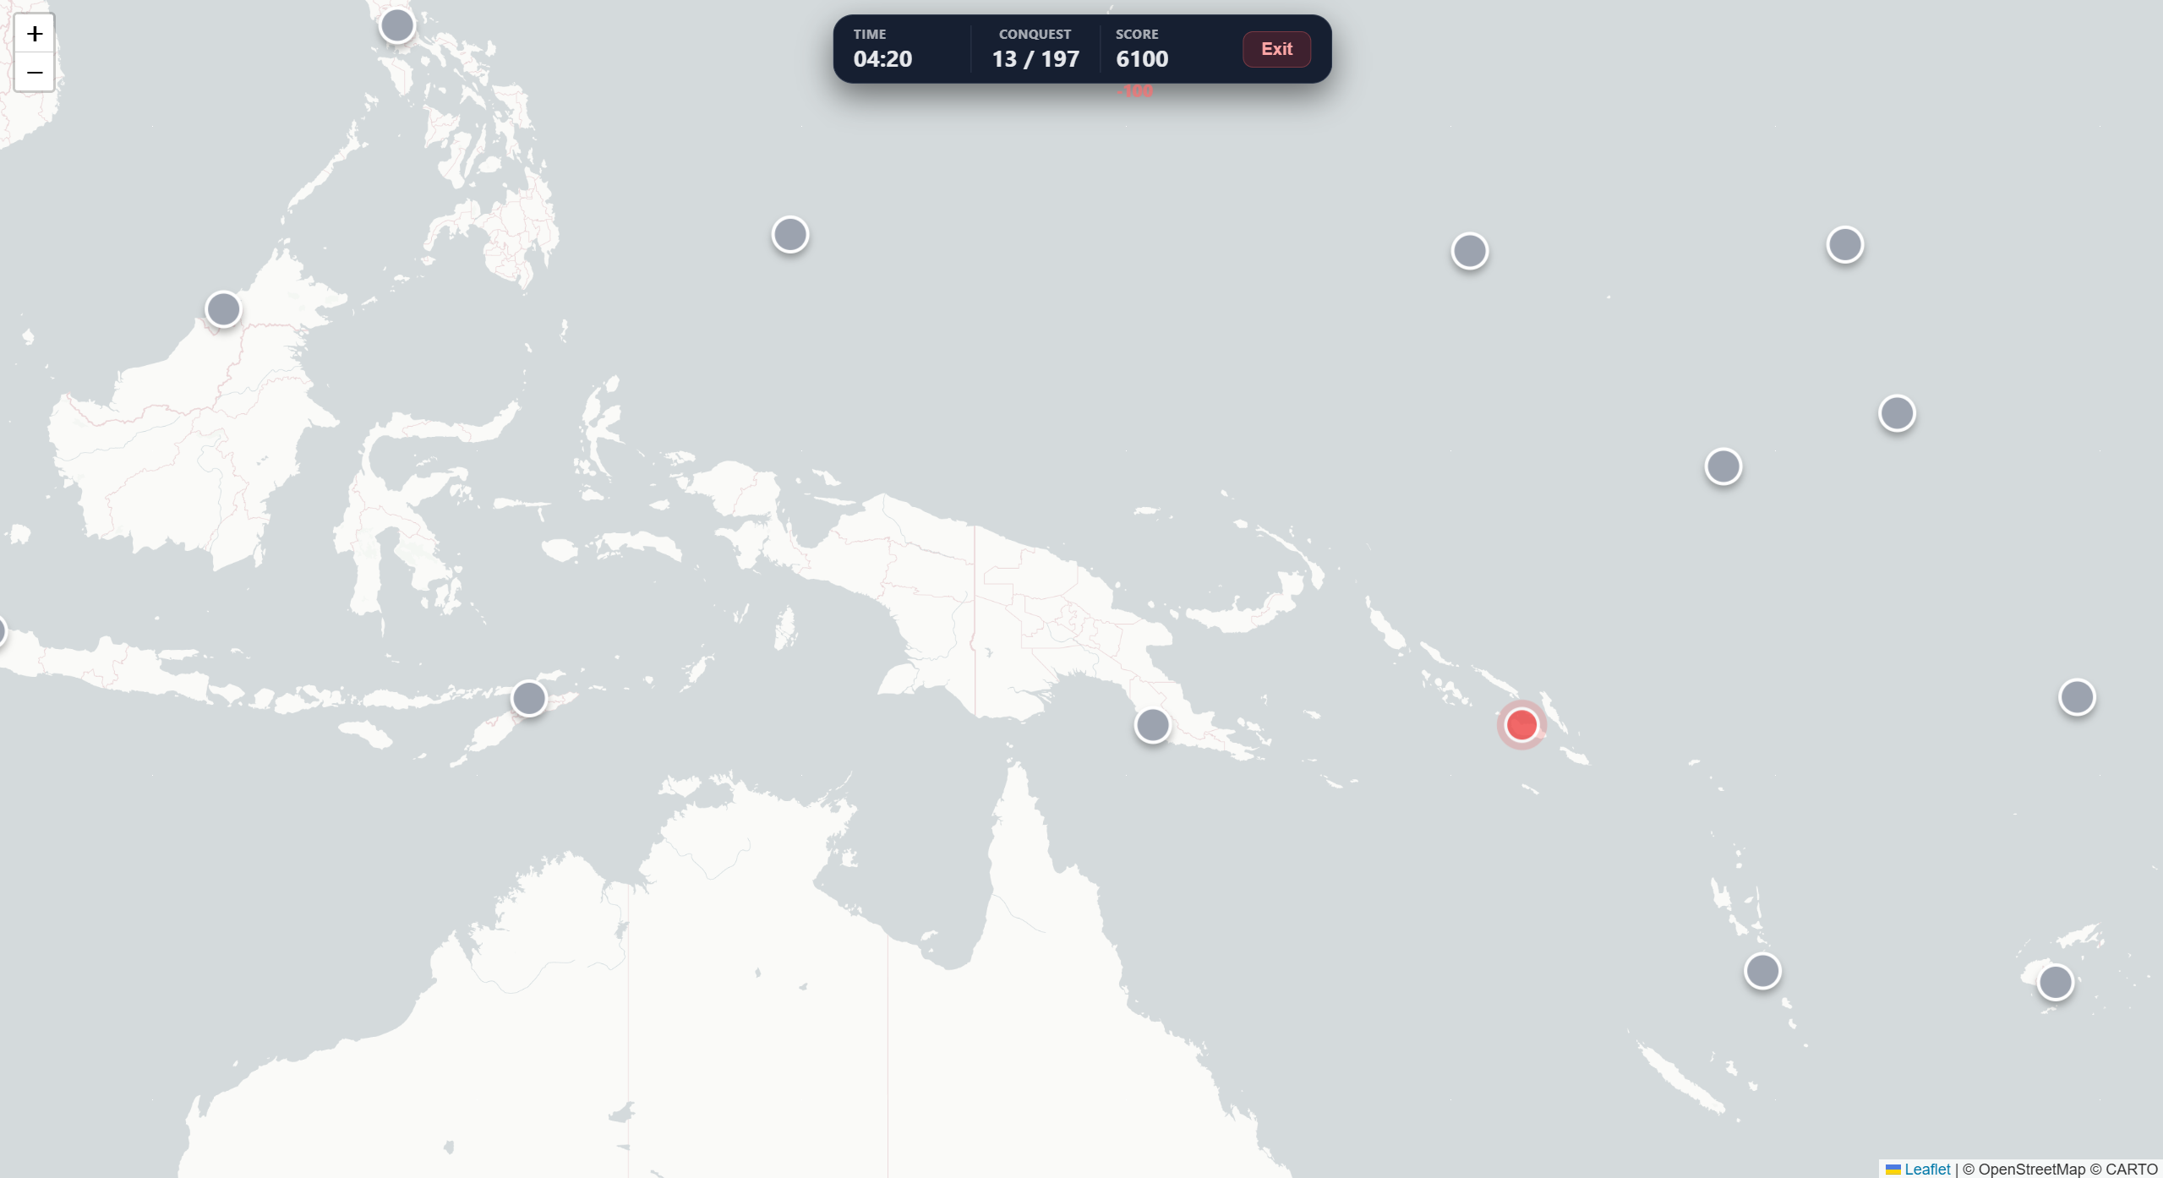

The game ends when the user completed all counties. They can view their score and time, along with the leaderboard.

The Capitalism game, similarly to the Conquest game, provides the user a map they need to complete, this time, with knowledge of Capital Cities:

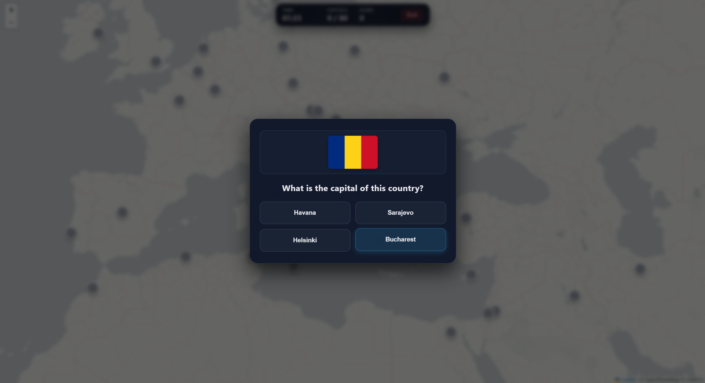

They are provided a list of capital cities they need to choose from, containing the correct answer and other random capital cities:

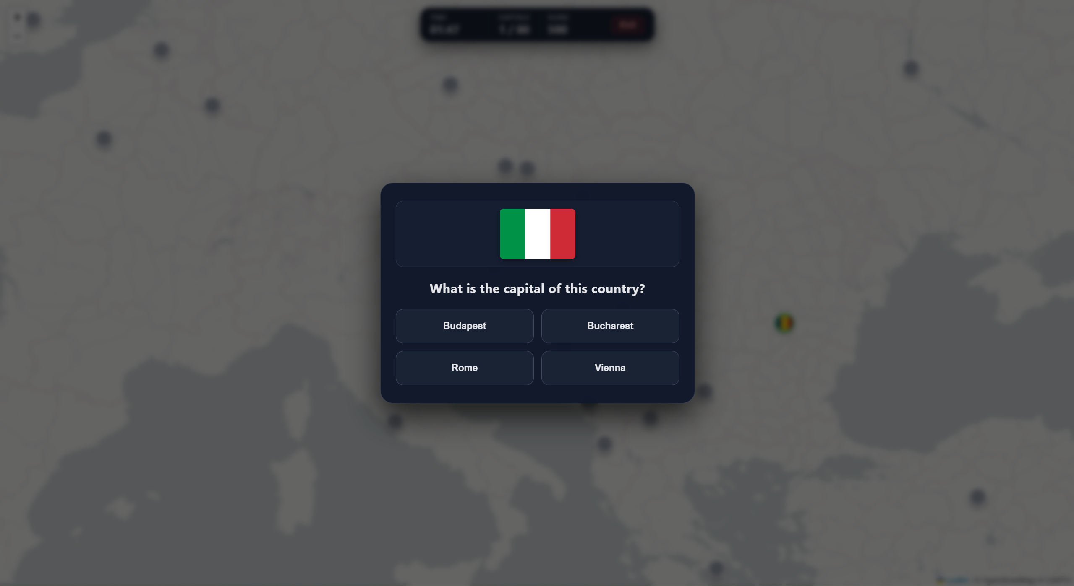

The game ends when the user completes the map, placing all capital cities. They can view their score and time, along with the leaderboard.

Features:

The Angular project uses Google API for Google Street View, Leaflet for maps and FlagCDN for the flags.

Demo Video: <https://youtu.be/0J1RV59stSU>